The following are general guidelines. Exact techniques will be determined by field conditions.

1.  **Allow chemicals to work**. Delay plowing long enough to allow the chemicals to work, but prior to the slush freezing to the pavement.

PLOWING

2. Normally plow snow to the right. Plowing technique is dependent upon the cross-section of pavement.

Crown- Plow left and right

Banked- Plow to the low side

Plow snow and slush to the low side so that when it melts, it will not run back onto the pavement.

3. At railroad crossings, snow and slush from the plow should be emptied along the shoulder in advance of the crossings. Avoid

carrying snow and slush onto the tracks. Snow and slush may become packed in the flangeways, creating a hazard which could derail a

train. Hard-packed snow is difficult to remove. Special effort should

be made to keep the crossings safe for highway and train traffic.

4. Intersections are plowed to the right. Leave cleaning of intersections to the cleanup operations unless it leaves a traffic hazard (example: heavy windrows or unclear sight distances).

5. At overhead bridges, exercise care and slow down. Do not plow

snow down upon railroad tracks or another highway.

6. Where possible, plow with the wind.

7. Multi-lane highways should be plowed in tandem. This eliminates the hazard of a windrow of snow lying between the passing and traffic lanes. Snow plows operating in tandem must be spaced a

sufficient distance apart to allow for safe operation of traffic.

8. Plow snow to the median, **only** if there is sufficient drainage facilities and storage area.

20

1. Plow back the shoulders, swing vehicle out at mailbox approaches.

2. Clean out intersections.

3. Plow turn lanes and ramps. (curb to curb)

4. Open up drains.

5. Clean off bridges.

6. Plow shoulders farther back for future snow storage.

7. Remove drifts that may become a future problem.

8. Restrict the use of materials to spot applications.

9. Cleanup equipment and get it ready for the next storm.

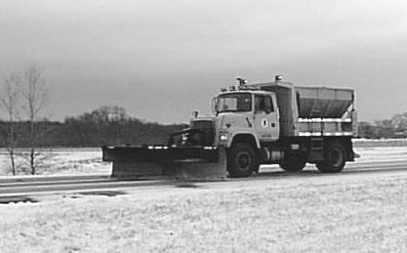

21