EQUIPMENT PREVENTIVE MAINTENANCE

Preventive Maintenance (P.M.) includes not only the repair of equipment, but more importantly, it includes the proper use, care, handling, daily inspections and service given to the equipment. These actions will increase the driver's and driving public's safety.

P.M. and daily inspections are part of the daily work routine. Each time a driver is assigned to drive, he/she is responsible for filling out an Operator's Daily Check List, while conducting the vehicle inspection. Their signature verifies that the

truck was properly inspected before leaving the unit location and the driver has accepted responsibility for that truck, during that shift. The Check List should be

given to the supervisor and if a defect is found, an Equipment Repair Request should be filled out, signed and turned in. With continuous inspecting and reporting of vehicle defects, the scheduling of repairs becomes more efficient and

should result in fewer repairs needed.

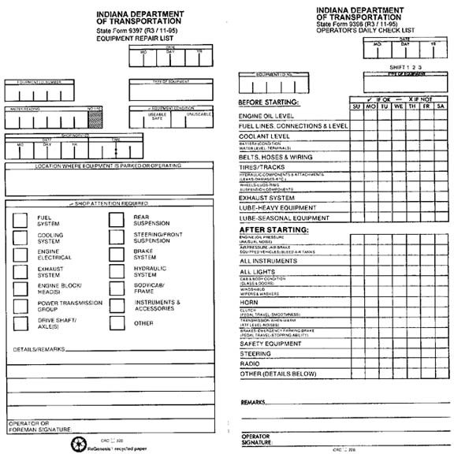

7

EXAMPLE

FLUID CHART FOR INDOT VEHCLES

**Always check with the shop for possible usage variances at every location!**

Before a fill-up, be sure the fuel type is correct. All water-cooled engines use a 50-

50 mix of antifreeze, except 1995 or newer GM products. Use Dex Cool antifreeze in mini pickups and sedans.

All engine oils are recyclable.

**International Trucks:**

Engine Oil: 15 W 40

Steering Oil: 10 W 30

Transmission Oil: Dexron II Hydraulic Oil: #46

**Ford Trucks (Single & tandem):**

Engine Oil: 15 W 40

Steering Oil: Dexron II Transmission Oil: Dexron II

Hydraulic Oil: #46

**Crew Cabs - GMC & Chevrolet:**

Engine Oil: 15 W 40

Steering Oil: Power Steering Fluid (Stockroom) Transmission Oil: Dexron II

**Crew Cabs - Ford:**

Engine Oil: 15 W 40

Steering Oil: Power Steering Fluid (Stockroom) Transmission Oil: Dexron II

**Mini Pickups:**

Engine Oil: 15 W 40

Steering Oil: Power Steering Fluid (Stockroom) Transmission Oil: Dexron II

**Sedans:**

Engine Oil: 15 W 40

Steering Oil: Power Steering Fluid (Stockroom) Transmission Oil: Dexron II

8