PLOW INSTALLATION

***The key to proper operation and the successful use of the equipment is to follow the proper safety installation procedures***.

Plows should be stored so that they can be easily accessed and attached. Once the plow is positioned on the truck, check the latches to insure they are secure and check hydraulic hoses for wear and leaks, before moving your vehicle. It is essential to utilize a blade that is not worn or

damaged, so the plow will function properly and not cause serious damage to the plow or road. Check the blade of the plow, by using the

1.5-inch rule (approximately two fingers' width), to measure the amount of wear. If there is a significant amount of wear and damage to the

blade, seek assistance to change the blade before proceeding. When

changing plow blades, raise the plow and block it securely before proceeding to loosen the bolts. Never allow placement of any portion of the body under the plow's blade or in an unsafe position.

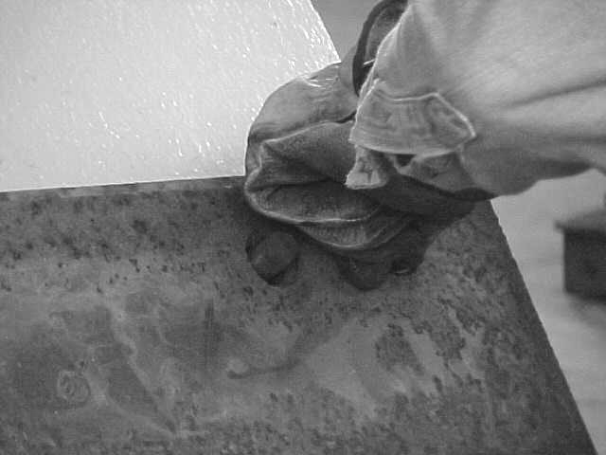

11